This article was originally slated for publication in the Washington Post Magazine… Alas, the magazine was discontinued but the author persisted until he found a platform. Related, I spent a couple hours with a Washington Post photographer for an extensive photo shoot that was to have accompanied the article. The author was given access to some of the pictures but not allowed to use them on the platform where the article appears, so, I am appending a link to my gardening experience album that contains these pictures, one of which (below) that was used in another article in the Washington Post.
Pictures link:
https://photos.app.goo.gl/kepmnvvLbuf5Ryte8
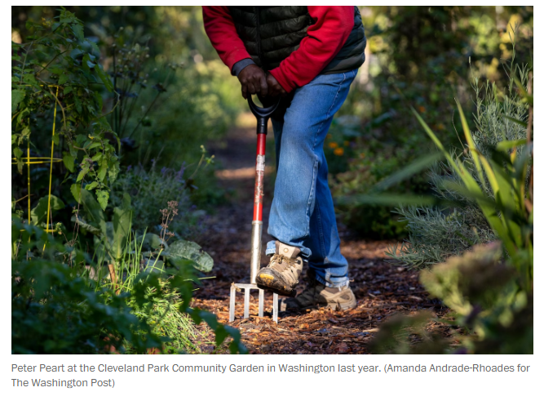
[This document is “side to side” and can be viewed by sliding each page from right to left or left to right.]

Gardeners in Arms


David Taylor
·Apr 21, 2023
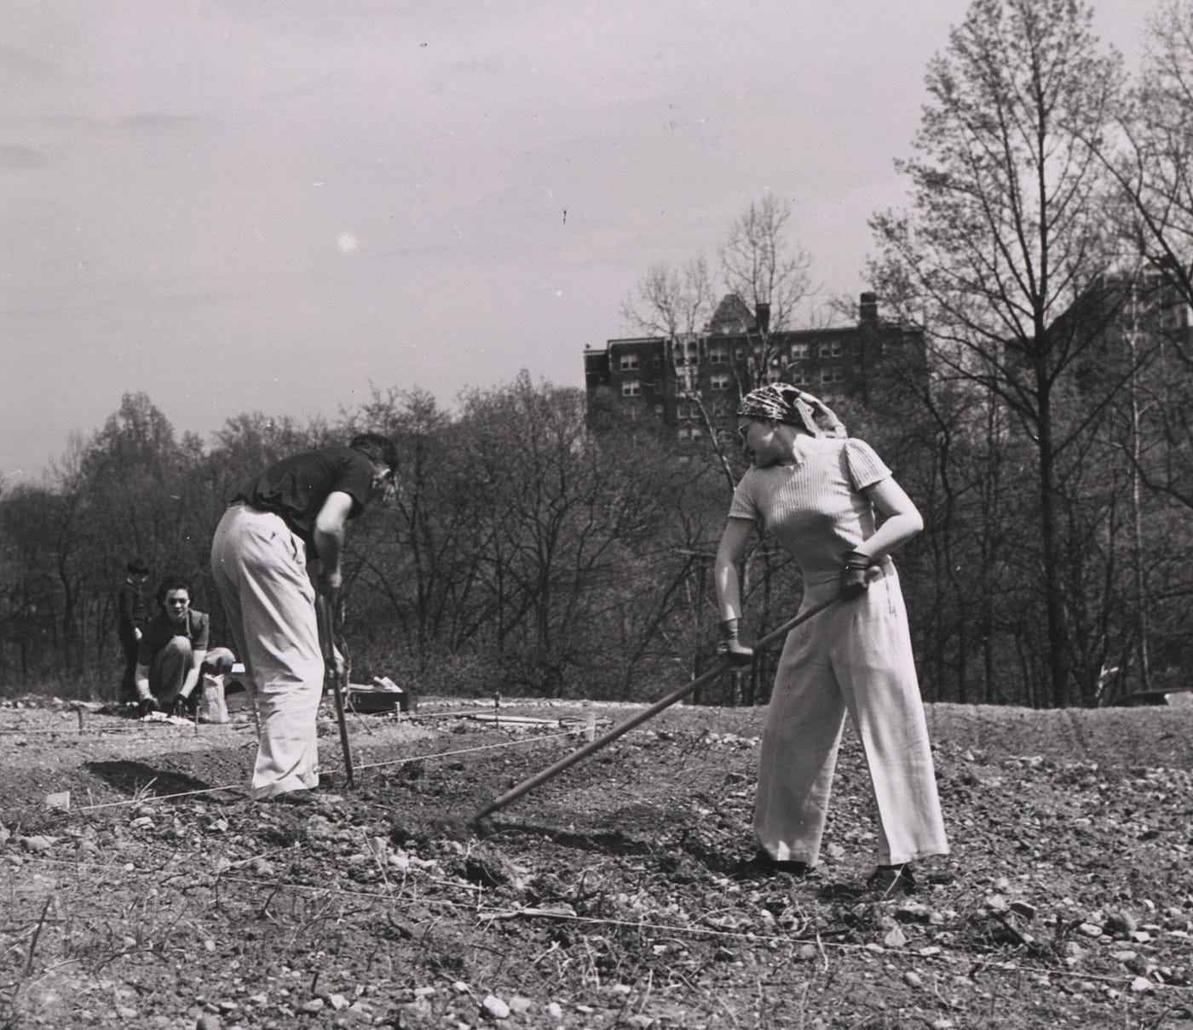
District citizens prepare the soil for the Cleveland Park victory garden in northwest, May 1943. Credit: Louise Rosskam/FSA. Courtesy Library of Congress
For years, the big, acre-sized garden I’ve walked past in our neighborhood has called to me. You can see the community garden from the woodsy park next to it, and from the four lanes of Connecticut Avenue. Walking by, I’ve eyeballed a few people at a time inside the fence, quietly focused as they fiddle with watering cans and digging tools. Late last fall, the space felt bigger, crawling with overgrown vines, reddening tomatoes, gourds, and sunflower stalks climbing up to 12 feet high. Finally, I was curious enough to start asking questions.
Turns out, this year marks the 80th anniversary of the community garden at Cleveland Park. It started as a Victory Garden in another time of unpredictable supply chains when lethal threats from America’s enemies prompted people to grow vegetables for self-sufficiency.
It’s tempting to view World War II as a time of unified purpose, but the city’s wartime council was acting fractious one night in January 1943. Saddled with bureaucracy, rattled by air-raid sirens that went off at random times, the council teetered on coming apart. “We’re just not going to take it anymore,” one member told the Washington Post. But one program the council agreed on was Victory Gardens. Irrigation pumps were ordered and a dozen gardens laid out across the city (“6000 Garden Plots Ready for Allocation” proclaimed the Post). Through the war, nationwide community gardens supplied 40 percent of the nation’s vegetable consumption.

Planting Alongside the Veterans
Through the decades since, that origin story bolstered the Cleveland Park community garden against meddling and foiled attempts to divert the land to other uses. Wedged between Rock Creek Park and an apartment complex, the garden has weathered wildlife and rogue planners with its own brand of weedy vigor.
The longest active member, Peter Peart, is one degree of separation from those founding farmers. He has tended his plot since 1980. He was 26 years old and four years out of Howard University when he learned about the Cleveland Park garden and signed up. “The cool thing,” he told me, “Is that it was an original victory garden.”
“For years after I joined, there were two original victory gardeners there,” he told me. One was known simply as Mrs. Bell. “She was like a doyenne of the garden.”
Mrs. Bell was also a living connection for another gardener, Helena (who asked to be identified by her first name only, for privacy). She tilled the plot next to Mrs. Bell, who even had her own shed. Helena got the impression that Mrs. Bell had owned the land previously. “When the war came, it was given for the people as a victory garden,” Helena said.
“For the war effort,” Peart says in a beneficent, plummy voice. “Mrs. Bell always said that: ‘For the war effort, dear.’” (No records survive confirming the Bells donated the land; it became park land and still is.) The group established an organization and by-laws. Mrs. Bell tended her plot into her 90s.
Many gardeners churn through much faster. Helena believes that people with previous gardening experience tend to stick. When she joined, applicants who were apartment-dwellers got priority. (People who had a house usually had a yard or other options for exercising their green thumb, went the reasoning.)
Once in, seniority dictated who got the desirable sun-drenched plots. “If you were a new gardener, you got the crappy plots,” Peart said. There was slow jockeying as growers rotated to brighter plots.
Like many gardeners, Peart’s choices of crops stemmed from his experience. As a kid in Jamaica, he would follow his uncle to a garden where the family grew their food. He would plant seedlings in the morning and dig them up in the afternoon. “I was looking to see if they were growing.” His grandmother teased him, saying “How are they going grow like that?” “But I’d say, ‘I don’t know if they’re gonna grow!’”
“Peppers is what I love,” he says, hot Scotch bonnets. Last year was among his best harvests ever. “It was an abundance of peppers. I make a lot of sauce, and I send it all over the world, just for friends.”
Helena, too, started gardening young. She grew up on a farm in Finland. “I had never grown tomatoes, peppers, that sort of thing,” she said, “it’s too cold over there. So I had a little bit of a learning curve.” When she joined later in the 1980s, she lived in an apartment nearby and would bring her two small children gardening. The younger one still helps out when he visits.
As the older generation passed, their plots were divided up to make room for more members, now at 120. Still the garden can’t keep up with demand; the waiting list is over five years long.

Newly Recognized Health Benefits of Gardens
During the pandemic, long-timers and newbies found refuge, fresh air, and balm in their garden tasks. Citywide, the Park Service saw applications for garden plots soar. According to Elsa Anderson, an urban ecologist at the Chicago Botanic Garden,” These places have really held on to their importance for people,” and gardeners have even “pivoted to having community events that are outdoors.”
“It’s a really, really good thing physically and mentally, to keep a person sane,” Helena agrees. She walks to the garden nearly every day in growing season.
Members tend to be early adopters, embracing no-pesticide policies and devoting space to pollinator-friendly flowers. Research says community gardens tend to promote food security, ecological sustainability, and reduce heat island effects (both directly with vegetation and indirectly, by simplifying food chains). The Cleveland Park Garden donates fresh produce to a local food bank, and the latest harvest, over 75 boxes of produce, was up from previous years. These services make cities more resilient to climate change.
Press enter or click to view image in full size
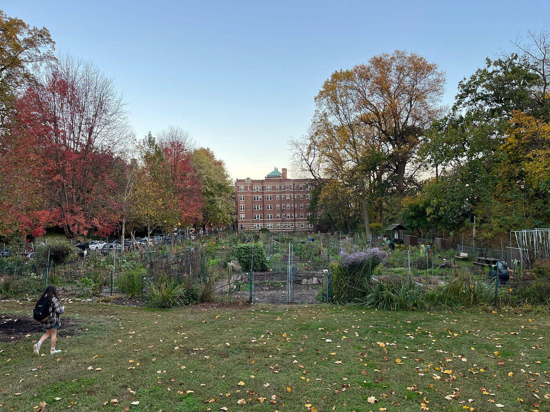
Gardeners in the Cleveland Park Community Garden, fall 2022. Photo: David Taylor

Powerful Origin Story With Policy Lessons
The garden offers a case study in the resilience of a community garden itself. In his 40+ years there, Peart has helped fend off outside threats. One came when the Barry administration in the 1980s considered charging the garden for water use. Peart recalls firing off a response, invoking the garden’s origin as a victory garden. Officials backed off and even promised that the city would cover the water bill “in perpetuity.”
Later came a danger from another direction. A nearby fire station renovation threatened to take land for an interim station. Peart emailed the chief. “I used the old victory garden thing,” Peart told me, smiling. “He rescinded the order immediately. He wrote back and said, ‘I’m sorry! We found another space.’”
Researchers find community gardens can play a bigger role than you might think from a patch of dirt. Garden champions can cut through the noise when their plots face encroachment by developers and officials who feel pressure for “commercial imperatives” higher than vegetables. A study in Glasgow, Scotland explains gardeners’ superpower against the friction of the status quo with the term “jumping scale.”
“The idea of jumping scale is that you ratchet your action and your mobilization up to higher levels,” Andrew Cumbers, one of the study’s authors, said in a video call, “from a very neighborhood level to a city level, or subnational level to a national level.” Urban gardeners engage their contacts and “out-maneuver more powerful adversaries,” and can drive bottom-up change.

Tools for Climate Resilience
The Scottish study noted that shaping “effective forms of organization and strategy to tackle climate change is one of the biggest management issues facing humankind…” For that challenge, behold the gardener.
The U.S. Department of Agriculture recently invited community gardens to join its federal People’s Garden initiative. “Local gardens across the country share USDA’s goals of building more diversified and resilient local food systems,” Agriculture Secretary Tom Vilsack said in a press release, “addressing climate change and advancing equity.”
For gardens that meet criteria, this can literally put them on the map. “There will be a website where we can locate these gardens and talk about the great work that they’re doing,” Terry Cosby, chief of USDA’s Natural Resources Conservation Service, told me. “We’re going to stitch these folks together.” That can help individual gardens jump scale. “If we’re going to meet this climate crisis,” he added, “every acre counts.” In a hat tip to Peart and Helena, he said, “A lot of folks in urban areas still have farming in their DNA.”
“The history of food sovereignty and access is deep,” says Elsa Anderson, the urban ecologist, “and it is just as relevant now as it was in the forties when the war effort was the major topic de jour.”
Helena agrees. “It would be nice,” she adds, “if the city could provide more [gardens] so that people wouldn’t need to be on such a long waiting list.”

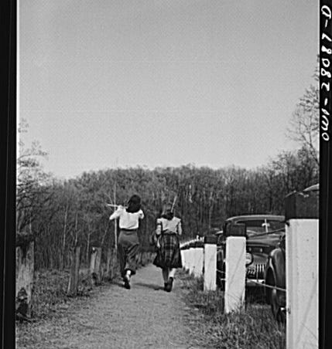
City-dwellers walk home after gardening. Credit: Louise Rosskam/FSA. Courtesy of Library of Congress



Written by David Taylor

233 followers
·293 following
Author & filmmaker on history, science, culture, food & travel. https://linktr.ee/dataylor1 Blog: https://davidataylor.org/blog/

