Columbia Lighthouse for the Blind's digital publication email, the Lamp Lighter, July 2025
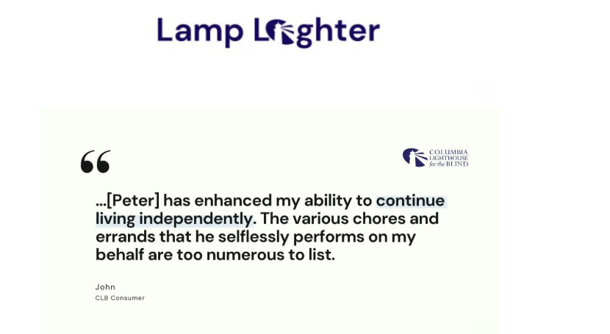
Consumer & Volunteer Spotlight

John, how long have you been connected to CLB?
John: “As best as I can recall, my first experience with the Lighthouse was attending the Day Camp at the building at 14th and U Streets in northwest Washington, DC. This would have been the late 1950s or early 1960s when I was about 8 or 9 years old. The camp offered wonderful experiences of various activities including crafts, visiting a nearby playground and a variety of field trips, including professional baseball games featuring the local team named the Senators at the time. As I further recall, I was one of the first group of campers. It was during my years at the Day Camp that I learned to play the adaptive version of baseball.
While attending Day Camp, I met and was mentored by Ann Chapman, then Director of the Camp. Miss Chapman was a remarkable person and became a role model during my formative years. Miss Chapman was an accomplished tap dancer (she often shared her story about an opportunity to go to Hollywood to train actors in the art of tap dancing) and taught the skill to those interested including myself. As a teenager, I took to the lessons keenly and thoroughly enjoyed Miss Chapman’s kindness and patience. In 1968, she taught me a very complicated tap routine in preparation for my high school talent show. The school talent show performance was well received, and I was given a standing ovation and calls for an encore. I returned to the stage where I performed a “soft shoe” number that Miss Chapman had taught me in anticipation of the warm reception she knew I was certain to receive.
And so began my long and continuing relationship with the Lighthouse. Further to this, for many years, I was an enthusiastic participant in the annual Braille Rallye.”
John - Peter is your assigned CLB volunteer. What is one meaningful support that he provides?
John: “Wow! So Many. But to summarize, Peter’s value to me is that he has enhanced my ability to continue living independently. The various chores and errands that he selflessly performs on my behalf are too numerous to list. But he has my gratitude.”
Peter, how did you determine to get involved with CLB as a volunteer?
Peter: “My interest in working with the people who are blind has deep roots from my college years when I worked for a NYC organization called Center for Independent Living (CIL) for the Executive director, Douglas Inkster.
My experiences and training at CIL were invaluable and never left me. When I retired, I knew I wanted to volunteer and thought -what better organization than CLB to offer my services. I had known about CLB from when I worked at CIL because the CIL developed training materials and manuals concerning independent living for blind and visually impaired individuals. This material was often shipped to many organizations supporting the blind, including CLB.”
Peter, what inspires you to continue your service as a CLB volunteer?
Peter: It gives me great pleasure and satisfaction to be able to help my clients. Through my six-plus years as a CLB volunteer, I have learned so much from my clients. Working with John is wonderful and meaningful. John and I have developed a great working relationship and a solid friendship. There is a great amount of laughter between us.”
As you reflect on your years, what is one recent highlight?
Peter: “John and I have shared many meaningful experiences over the years. However, earlier this year when John was asked to be part of a documentary film series sponsored and hosted by Docs in Progress arts organization in Silver Spring, MD, he was thrilled. John was filmed and interviewed by students from Montgomery Blair High School who would later create a 4-minute documentary highlighting John’s groundbreaking transition as the first student who was blind to matriculate through the Maryland public school system.
At the recent premier of the film, two other short documentaries, also made by local high schoolers, were presented. My companion Nan and I, along with friends and supporters of the subjects of the film were present. The program was well received. Later, John would reflect, 'Having you at the premier of the documentary meant everything to me.' I was deeply moved by these words, and it further cements our relationship and adds to the inspiration to continue as a CLB volunteer.”
Watch the documentary about John here

